Reverse Engineering the Western Alphabet

The Western Abecedary and the Pre-Sanskrit Abugida [1], [2] Compared

How the Western Alphabet is dependently related to a very early South Asian Abugida

|  |  |  |
| --- | --- | --- |
|  | **Wim Borsboom**  Independent Researcher  Victoria, Canada  wimjborsboom@gmail.com |  |

# ABSTRACT

This hypothesis *“Reverse Engineering the Western Alphabet”,* proposes how well before 3,400 BP the current western sequence of alphabet phoneme characters (the linear ABC or *abecedary*) was modelled after an early (ancient) simple pre-Sanskrit Devanāgarī phoneme character grid (an alphabet-like *abugida*). Their similarity will become evident:

* when it is shown that the western linear alphabet can be converted into tabular format,
* when a simple early Devanāgarī abugida table of 20 characters has been *reverse engineered.*

When they are put side-by-side in table format, certain anomalies are observed, explained and corrected. It is then described, how and when the anomalies occurred in antiquity. Subsequently:

* the tables’ initial dissimilarity (because of historical errors that occurred over time) of 25% (5 of 20 characters) and
* their later-corrected similarity of 90% (18 of 20 characters) is calculated, showing a close match between them.

It is then shown, how a 1,400 BCE Ugarit (Syria) cuneiform clay tablet *abecedary* provides evidence that a “West-of-India” style, irregular alphabetic sequence was already in use - a 3,400 year old alphabet that eventually became westernized. Thus, we arrive at a *date before which*the first copying and modelling of the western alphabet after an ancient Indian abugida must have taken place.

## Keywords

Linguistics, Archaeo-Linguistics, Epigraphy, Phonetics, Alphabet, Sanskrit, Devanāgarī, Brāhmī, Pāṇini, Ugarit.

# INTRODUCTION

Over, at least the last 3,400 few people have wondered, why the western alphabet’s sequence of letters are organized in the order they are, that is… if there is any order at all, especially when one notes that the vowels, which one would expect to be grouped together, seem haphazardly spread throughout the linear string of alphabetic letters.

Students of modern and ancient Indian writing have never wondered about that, because as soon as they learn to write and read the Devanāgarī letters (Devanāgarī from “deva” - god, and “nāgarī” - script of the city), they learn about their great antiquity, which goes back, at least to Pāṇini (6th, 5th or 4th century BCE), the great Northwest-India Sanskrit philologist, grammarian and scholar. He distinguished some 1,700 basic elements (sentences, nouns, compound nouns, verbs, vowels, consonants, etc.) and categorized them into classes. Devanāgarī, which is used to write Sanskrit, Prākrit, Hindi, Marathi as well as Nepali, ultimately developed from the Brāhmī alphabet.

Western alphabets, *according to consensus*, go back to a Semitic proto-alphabet (Levant, 2nd millennium BCE), which in turn can be traced back to Proto-Sinaitic, which developed in Ancient Egypt. The first “true” alphabet was from Greece, and was adapted from a Phoenician one. The classic and modern Latin alphabets derive, via the Etruscans, from the Greek.

Different from consensus opinion, this paper proposes and details, how - well before 3400 BP - the current western Late-Roman Alphabet character sequence[3] [1] (the linear ABC or abecedary) was modeled after a pre-Sanskrit Devanāgarī-like character grid (abugida or alphasyllabary).

Because of the difference between linear and grid (tabular) formats, that modeling can of course only become evident, when enough of a similarity is observed between the linear abecedary characters and the tabular sequence of letters in a Pre-Ashokan Brāhmī [2] or Pre-Sanskrit abugida [3]

1. This study demonstrates how the western alphabet sequence can be put in a tabular format, and can, subsequently, be compared side-by-side with a pre-Sanskrit Devanāgarī-like character grid.
2. Even if the characters within the western alphabet (abecedary) look randomly distributed, it will be shown how that letter-sequence was originally based on an ancient orderly pattern, a pattern that categorized sounds by how and where they were articulated in the mouth.

It will be demonstrated (see **Part Two - Discussion, Stage 7 - Aftermath and Dating**) how a Ugarit cuneiform clay tablet abecedary from Syria (ca 1400 BCE) provides evidence that a “West-of-India” style, irregular alphabetic sequence was already in use - an abecedary *modeled after a very early form* of a pre-Sanskrit Devanāgarī-like abugida.

1. Steps will be retraced of how this modeling and/or copying process took place, a process that also included several “errors and omissions” made by one or several ancient scribes most likely from the Near-East.
2. It is shown that these errors eventually resulted in the apparent disorder of the western alphabet’s character sequence.
3. By tracking these “copied” errors across a number of ancient abugidas (alpha-syllabaries), including Pre-Ashokan and Ashokan Brāhmī, and comparing the result to a Ugarit (Syria) cuneiform clay tablet from 1400 BCE [3], we arrive at a **end date** before whichthe first modeling and/or copying must have taken place.
4. When the western alphabet - *once it is put in tabular format* - is superficially compared to an earlier and simpler “*reverse retro-engineered”* Sanskrit abugida (as detailed in **Stage 3 Reverse and Retro[4] Engineering** of the **Methodology** section), a percentage of similarity of only 25 % (5 out of 20 characters) is calculated.
5. However, after the error identifications, and considering the varying but close pronunciations of several comparable characters in side-by-side alphabet and abugida grids, as well as focusing on the placement of several *Late*-Roman[5] Alphabet characters in their appropriate vowel, labial, guttural and dental columns (illustrated in detail) a 90 % match between them is obtained.

# METHODOLOGY

Some specific research methods applied in this hypothesis, *even if they are not uncommon in other fields of research*, are normally not used in linguistic studies of this sort. They will be explained extensively in the **Methodology** section.

Even with the use of this methodology, dating of events was not directly possible as no direct time-data of the time periods covered in this study are available. The reason will be explained later.

Also, as the study in this paper is based on a previously published book[6] [4, 5], certain literary forms in the book - which in popular publications would be quite acceptable - have been retold here in an extended narrative form, the nature of which narration will also not often be found in studies of this type. I believe though, that this does not diminish the value of this paper, especially since the principle of this paper’s hypothesis - *the dependent relationship of the western alphabet on a very early South Asian abugida* - is well demonstrated.

When the name “India” is used in this study, it refers to ancient India on the South Asian Subcontinent, a land with different borders than current India.

# *The author wishes to express his gratitude beforehand for your indulgence.*

## Stage 1 - Inklings & Serendipity, the Author’s Personal Story

From when I was in grade 1 (1960), when I asked my schoolteacher why the ABC letters were in the order they were (disorder really), and when I did not get a satisfactory answer, I always wanted to find out why the alphabet letters were in that particular order, “Why was ABCD followed by EFG, and why were the vowels not recited together?”

Much later in life (1975), when I became interested in Sanskrit, and was studying the Devanāgarī alphabet, I was struck by the neat, linguistically scientific order of the Sanskrit Devanāgarī alphabet letters, especially the way they were organized according to specific locations in the mouth, where they were voiced.

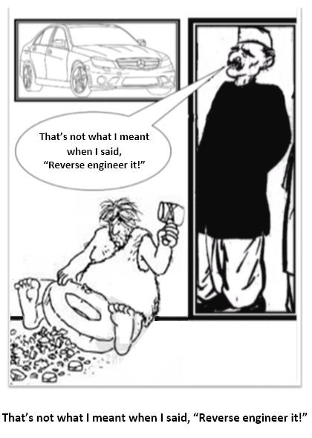

Figure 1

That’s not what I meant, when I said,  
”Reverse engineer it!”

One day in 1982 (I was a Montessori teacher then), these two issues *popped* into my head simultaneously, and I knew that I was going to find an answer that would show that there *was indeed* order in the western alphabet and that, one way or another, the Sanskrit Alphabet would help me finding it.

## Stage 2 - Finding Patterns

When I decided (that “one day in 1982”) to “bunch” the vowels together column-wise, and organize the remaining letters in a tabular format adjacent to the vowel column, a pattern emerged. When I recognized that a similar pattern was evident in the Sanskrit alphabet (although categorized in more detail), it became obvious that the patterns, as they were so similar, could well have a dependent relationship.

Looking for patterns in dissimilar sets of data, and finding comparable patterns from which certain conclusions could be drawn, is done in the field of statistics.

Many years later, I decided to make enquiries about the legitimacy and validity of this “pattern seeking technique” with Mr. Harsh Pant of *OpsVeda Asia* (Bangalore), a software company familiar with data pattern searches and drawing conclusions from them. Mr. Pant explained that the method I used, and which produced my results, is very similar to the data processing methods employed by statisticians and software quality control engineers, to discern patterns, discover trends or (even) trace data errors or fraudulent transactions. By applying reduction, abstraction and simplification algorithms to metadata, patterns are discerned in statistical and software data, enabling its engineers and researchers to glean relevant information from them.

## Stage 3 a, b, c, d, e - Reverse and Retro-Engineering

Regarding the history of the *typographical formation* of the Roman Alphabet letters, much has been written. Visiting libraries, accessing encyclopedias and searching the internet, offers a plethora of resources. But as typography - the graphical presentation of letter shapes (graphemes), rather than the sounds (phonemes) of letters - is not the topic of this paper, it suffices to list resources in the **References** section [7, 8, 9, 10, 11, 12, 1].

Little is known about the *sequentiality* of the graphemes/phonemes. *If* anything is mentioned it is along the following lines:

"No one is sure why those particular sequences of letters. Maybe it is some mnemonic device that we no longer understand…"

~ Lawrence Lo

"[...] Take, for example, the alphabet in the English language. The letters have been arranged in a haphazard manner. Why is B followed by C? Why is D followed by E? There is no reason why F comes after E, P is followed by Q, or Q is followed by R.”

~ Judge M. Katju in “Frontline Magazine” Jan - Feb 2012 (The Hindu, India)

Because, apparently, nothing is known about the history of the *sequence* of the alphabet letters, *meaning there is no direct evidence*, a different method was needed to *virtually dig into archaeo-linguistic mounds* (which of course can *only* be done virtually).

One way to do that is by working backwards in time, by making logical conjectures about what might have happened in the past, a sort of “reverse engineering”, to hypothesize or find simpler earlier forms deduced (or rather reduced) from later or current complex data or objects, a way to make logical conjectures about what might have happened in the past.

A quote from an interview [6] on this topic about “reverse engineering” in an online magazine MyInd.Net between Mr. Nilesh Oak and the author:

***Nilesh****: […] Everybody knows how the Japanese, Chinese and South Koreans more or less “engineer” and fabricate their products (at least they used to): electronics, cars, cell phones and what not […] You know as well as I do, they either take the to-be-copied product apart and study its components and copy them, and then take it from there, or they figure out by simple inspection what the product is assembled from and how those parts must have been manufactured and how they fit together. And then, if needed with variations, they will reconstruct that product as “their new original” in their own way and possibly even better than the copied original.*

***Wim****: Right, or instead of producing something bigger and better, say a car, reverse engineering could also produce something simpler, more basic, without frills, bells and whistles, just the essentials. […] So, based on what is existing, pretty well everything can be deconstructed into initial or simpler elements. This also means that a current sophisticated product shows its developmental history when one analyses its components and construction.”*

As the western alphabet has only twenty-six letters, and if, as proposed here, it was in *days of yore* modelled after a Pre-Ashokan Brāhmī alphabet (the current Devanāgarī abugida has, give or take, 50 characters) then there must have been a time that a smaller, simpler version of an ancient Indian alphabet existed, one with roughly only half the current number of characters.

It will be shown in this paper, that it is indeed possible by *deconstructing* to subsequently reconstruct or *reverse retro-engineer* a simpler ancient Indian alphabet. It then becomes possible to compare the western Late-Roman Alphabet with the *reconstructed* ancient simpler Indian abugida, and find correlations and pattern similarities. That then, should help in finding, as proposed here, the **dependent** relationship of the western alphabet on the eastern abugida.

## Stages 4, 5 and 6 - Recognizing “Swap & Shift, Mix & Match, Insert & Delete”

As will be seen in the **Discussion** section (the sub-sections **Inklings & Serendipity& Finding Patterns, the Author’s Personal Story** and **Reverse Engineering**) the methods and processes used will result in *two suitable tabular grids* that can be compared:

* A “Western” four by five columns-and-rows table, based on the western abecedary’s alphabet sequence of letters,
* An “Indian Script” table, four by five columns and rows, based on the Devanāgarī abugida.

## Stage 7 - Aftermath and Dating

Comparing the oldest abecedary found (Ugarit, Syria, ca 1400 BCE) with an ancient reverse retro-engineered western alphabet *in tabular format*, made estimating a *date before* possible.

# 

# STUDY

When one looks cursorily at the way the western alphabet characters are strung together, one hardly ever wonders why they are in the sequence in which they are.

From the age of being a preschooler we have become so familiar with the alphabet’s sequence of sounds, that to most of us, when we recite or sing the alphabet, it might even feel like we are reciting or singing an age-old rhyme. Could it be though, that there is actually “rhyme *and* reason” to the fact that ABCD is followed by EFG?

At first sight, the linear western alphabet sequence (abecedary) appears to be random, but by focussing on just the vowel phonemes (which seem to be randomly distributed), it is noted that the vowels (although separated from each other by various seemingly random consonants) appear in the well-known vowel phoneme sequence A E I O U, a traditional list of vowel letters in the Roman alphabet[7].

## Stages 1 and 2 - Inklings & Serendipity & Finding Patterns, the Author’s Personal Story

The first inkling I had about a possible order in the sequence of the ABC letters in 1950, was when I asked my grade 1 teacher, “Why are the ABC letters in that order?”. When she answered, “Well, they are in alphabetic order of course!”, I was quite astounded by her non-satisfactory response, and decided that sooner or later I would find that order... if there was any.

In 1975, familiarizing myself with Sanskrit to study the Bhagavad Gita, I was struck by the neat tabular order of the Sanskrit Devanāgarī alphabet, something that was entirely missing in the linear western alphabet.

In 1982 (being a Montessori schoolteacher then) after school, while I was in a Canadian espresso bar, an idea popped into my head, and while grabbing a napkin and a pencil, I started reciting the western alphabet to myself, *on a hunch* putting emphasis on the vowels A, E, I, O, U where they appeared in the alphabet.

Figure 3

The “napkin” grid entered in a

4 by 5 column and row table.

Unfortunately, in this publication, the colours do not show, but if they did, the periodicity would be more noticeable.

If the colours would show:

1. 1st column - the vowels would be blue,
2. 2nd labials column mostly red,
3. 3rd gutturals column mostly yellow,
4. 4th dentals column mostly green.

We will find out later how the asterisked letters K, L, M, and H ended up in the wrong columns. The asterisked J, Y, and R found their place for different reasons. That will be explained later.

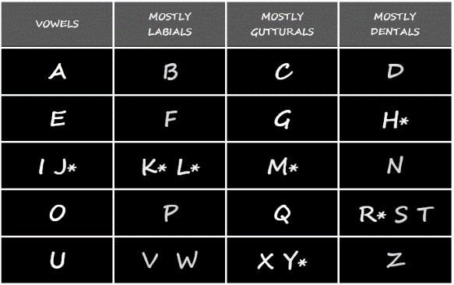

I was thinking, “What if they showed some order?” So I repeated:

“A E I O U”

I took the pencil and scribbled them on the napkin, but in vertical order. Then - again on a hunch - I added the conso­nants to them, but in a shortened row format as in Figure 2.

Next day back at school, I wanted to study the *seemingly random* linear alphabet character sequence more carefully, and I copied the napkin notes onto the blackboard (Figure 3). I drew a four-by-five column & row grid, and while entering the letters, I applied colour coding (not showing in this publication) to distinguish the vowels and consonants[8] according to their phoneme classifications: *vowels blue, labials red, gutturals yellow and dentals green.*

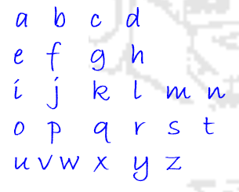

Figure 2

“Napkin” grid (1982)

Notice the asterisked letters J, K, L, M, Y, H, R in Figure 3. As is evident, some creative fitting was applied, for which, incidentally, the reasons would be discovered later. In any case, a certain measure of periodicity became immediately noticeable.

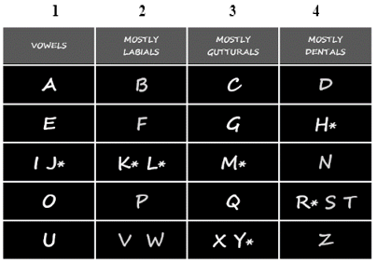

Figure 5

Compare this table with Figure 4, which is the result of the reverse retro-engineering method applied to the current Sanskrit Devanāgarī abugida, with the intent to reconstruct a preceding more ancient and simpler abugida.

Notice the sequence   
of the phoneme columns:

1 vowel, 2 labials, 3 gutturals, 4 dentals.

Figure 4

This table (see also Figure 15, Step 3) is the result of the reverse retro-engineering method applied to the current Sanskrit Devanāgarī abugida to reconstruct a preceding more ancient and simpler abugida.

Those familiar with Devanāgarī script, will notice the sequence of the phoneme columns:

1 vowels, 2 gutturals, 3 labials, 4 dentals.

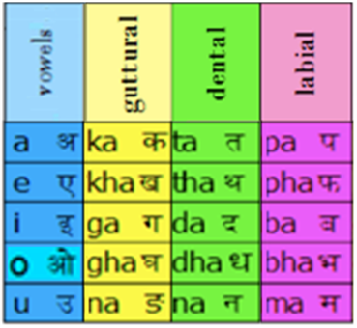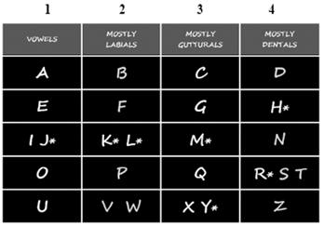

Thus, the abecedary’s sequentiality was maintained, while periodicity in the seeming random distribution of its characters became recognizable.

The first column in Figure 3 lists the vowels A, E, I, O, U, the second column contains characters of which *most are labials* B, F, P, V, W, the third column shows *mainly gutturals* C[9], G, Q, X, and the forth column *mostly dentals* (D, N, S, T, Z).

Initially, the significance was not yet evident about the asterisked characters that fitted into seemingly inappropriate fields, e.g. in the vowel column the J, in the labial column the K and L, in the guttural column the M and Y, and in the dental column the H and R).

That though, eventually became helpful in discovering how during the process of copying and modelling the western alphabet table, a number of errors had crept in, which errors actually established - by using as evidence the Ugarit (Syria) clay tablets (Figure 29a) - that after 3400 BP the originally tabular western alphabet acquired its linear and thus apparent disordered sequence. Compare Figure 5 with Figure 4, which is an ancient, simpler form of the Sanskrit Devanāgarī abugida grid (retro-engineered in the following section **Stage 3 - Reverse and Retro-Engineering**), and notice certain discrepancies: e.g. in the western alphabet table (left) the fourth column lists *dentals*, while in the Devanāgarī table (right) the fourth column lists *labials*. This discrepancy and additional insertions (asterisks) - some caused by ancient errors - eventually led to the conclusion that there exists a dependent relationship between the Western alphabet and an early form of the Sanskrit Devanāgarī abugida (alphasyllabary), that we can approximately date. When we pay attention to the arrowed boxes in Figure 6 and notice their sequence, we see again that in Figure 5 the western alphabet table’s columns are in a different order. (We will investigate how that happened in **Stages 4, 5 & 6 - Swap & Shift, Mix & Match, Insert & Delete**)

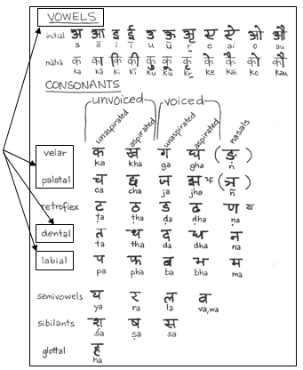

Figure 6

A study-group handout. (Pritchett)

## Stage 3a - Examples of Previous Rudimentary Reverse and Retro-Engineering Results

Regarding the history of the formation of the ***sequence***of the western alphabet’s graphemes/phonemes little is known, nothing was found in available-library searches.

It was only after publishing an informal internet report to a Facebook independent research group about my tabular alphabet findings, that I was sent the title of a booklet by Laksman S. Wakankar’s “*Ganesh Vidya - The traditional Indian approach to Phonetic Writing*”. It shows Mr. Wakankar’s “periodic” phonemes table (1968), (Figure 7) [14]. Mr. Wakankar’s table[10] is very much like my chart (Figure 2), but he did not notice the different phoneme-class ordering (*vargas*). Also, he did not provide an analysis as to any possible dependent relationship with the Devanāgarī abugida vargas.

Subsequently, Mr. Rajendra Gupta sent me a link to his blog [5] “*DNA of Words*” showing his “periodic table” of alphabet characters (2012), (Figure 8). Mr. Gupta is featuring additional columns for the fricative and semi-vowel phonemes, but without further analysis about why the phoneme classification order differs from Devanāgarī abugidas.

Recent Internet searches produced two significant finds in support of this hypothesis: L. A. Wadell [16] (1927), (Figure 9), and Frank Moore Cross Jr et al. (1960),(Figure 10).

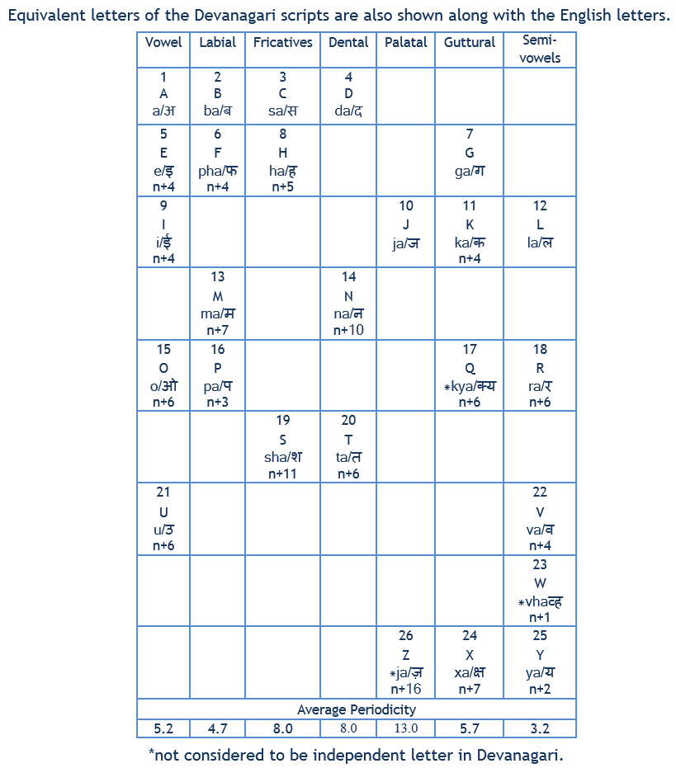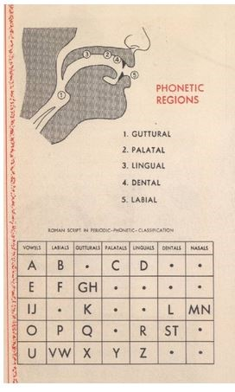

Right - Figure 8

Gupta’s Periodic Table of Phonemes 2012

Left - Figure 7

Wakankar’s Table of Phonetic Regions 1968

The tables in Figures 7, 8 and 9 show charts that are in principle much like my impromptu version (Figure 2) of a “Periodic Chart of Characters”[11].

In a discredited work, due to the fact that it is in favour of the now outdated Aryan Invasion Theory, L. A. Wadell (1927) *nevertheless* made observations as shown in Figure 9. But again, just like Mr. Wakankar and Mr. Gupta, he did not notice that the order of the phoneme classification differed from Devanāgarī abugidas, nor did he succeed in finding out how and why certain characters were placed where they are now. However, his remark that, “*This appears to indicate that originally the letters were arranged for learners in perpendicular rows, according to their phonetic class qualities, and that* ***later on they were read transversely across the board, which gave them the apparently capricious and irregular order in the modern alphabet.****”* is astute and significant.



Figure 10

In 1955 a rare abecedary tablet was found in Ugarit. Parallel vertical columns show ten Ugaritic signs (obverse) and ten cuneiform syllabic signs transcribing the Ugaritic (reverse).

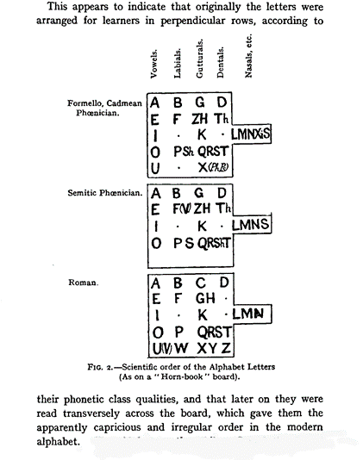

Figure 9  
 L. A. Wadell 1927

Ugarit tablets (Figure 10) from ca 3400 years ago, provide evidence that **columnar** abecedary representations were in use together with linear ones. Figure 10 shows a 2-column intermediate transition stage between the 4-column tabular abecedary format and the later linear format. (Frank Moore Cross Jr, Thomas O Lambdin: 1960) [3].

## Stage 3b - Reverse Retro-Engineering

A way to retro-engineer (see Footnote 4) is by working backwards in time, by making logical conjectures about what might have happened in the past, a sort of “reverse engineering”, to hypothesize or find possibly simpler earlier data or objects, deduced (or rather reduced) from later or current complex data or objects.

Ideally, this project (which formally began in 2012) should have started by comparing the cuneiform Syrian Ugarit Abecedary (see Figure 28a) with Kharosthi, Gupta, Pre-Ashokan Brāhmī and Ashokan *lipi* (writing systems), but as my original discovery in 1975 went via Devanāgarī and the western alphabet, and as western characters are more widely recognizable (*and* there is no need to deal with multiple series of non-western characters), I believe that the result and conclusion of this study is valid in its current form, especially since the principle of the hypothesis of this paper - *the dependent relationship of the western alphabet on a very early South Asian abugida* - is well demonstrated.

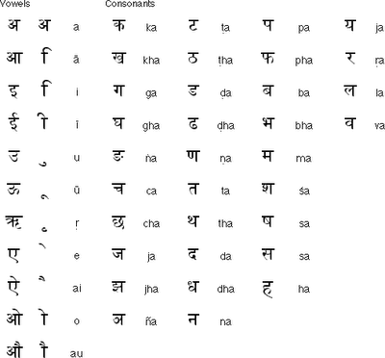

Figure 12

Consonants in a horizonal format.

Pivoted 90 degrees.

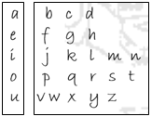

Figure 11

The author’s first tabular “napkin” version.

In preparation for this “reverse engineering” process, it was important to match what I had initially scribbled on my napkin (Figure 11) with a format in use now.

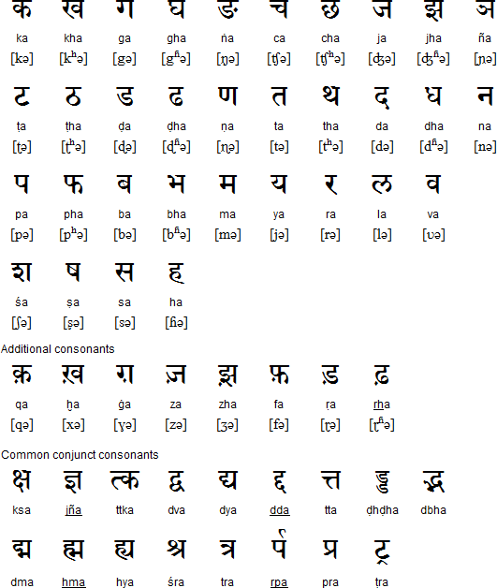

Figure 13

Consonants in their usual vertical format.

I found a current Sanskrit Devanāgarī abugida (Figure 12) that listed the *Vargas* (phoneme groupings) similarly. Usually Devanāgarī abugidas have a format as in Figure 13 (ka ta pa, etc. vertically.

Check the ovals in Figures 11, 12 and 13, and note that the consonants b c[12] and d (when pronounced as b k d) are phonetically close to ka ta pa, although, they are in a different order.

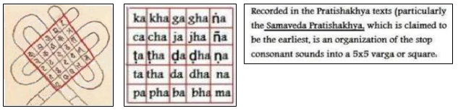

Figure 14

Left: Earliest Jain abugida grid

Right: Transliteration

## Stage 3c – Looking for Older Models

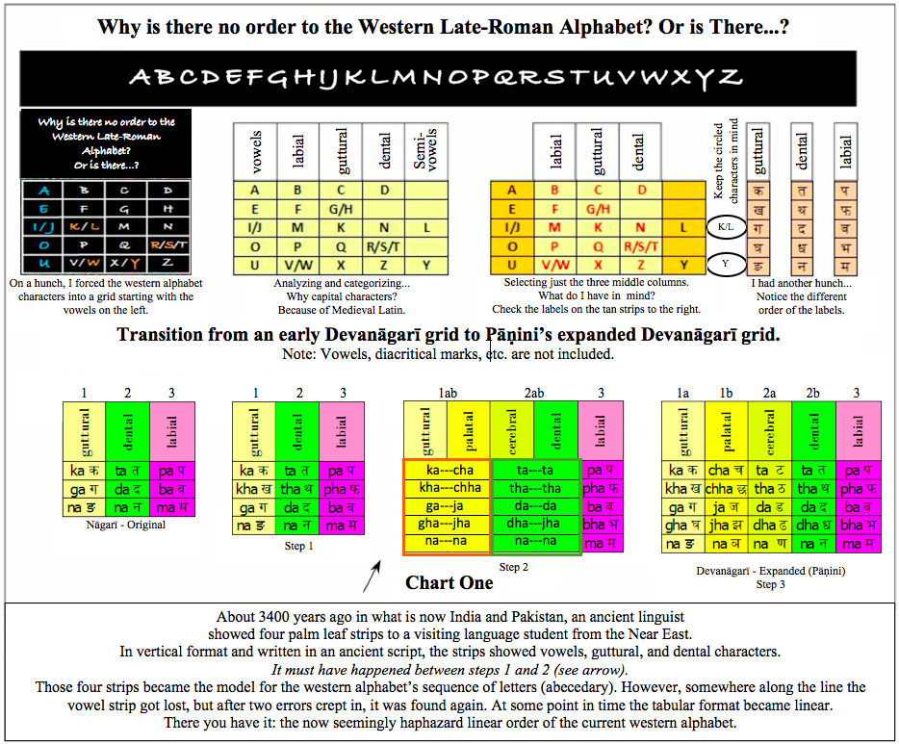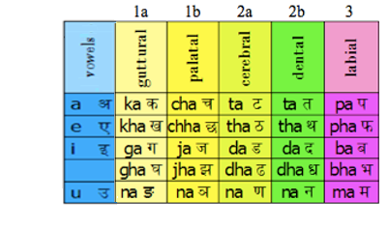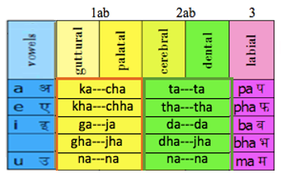

Step 5

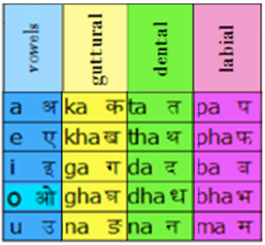

Step 4

Step 3

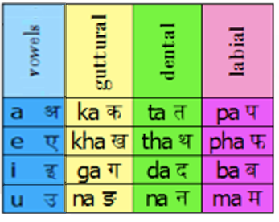

Step 2



Step 1



Step 0, possibly the first consonants recognized



Figure 15

“Reverse Engineering” Iterations.

If indeed the western alphabet sequence was based on an ancient Devanāgarī abugida, then there must have been an abugida in the past with 25 characters or **half** the current - give or take - 50 characters.

The Jain religion has a rich tradition in Abugida grids (Figure 14) [17], and its calligraphed literature was very useful in finding models for the hypothesized abugida grids of Figure 15, especially for Step 5 (left).

Notice the 5x5 grids of 25 phonemes.

## Stage 3d - Retro-Iterations

The western alphabet has 26 characters, and if, in the *days of yore,* it was modelled after a Pre-Ashokan Brāhmī - or even an early Sanskrit Devanāgarī abugida - which has traditionally 50 characters (give or take), then there must have been a time that a simpler version, with roughly half the current number of characters in an ancient Indian alphabet, existed.

Regarding vowels and consonants, the Pāṇini (6th, 5th or 4th century BCE) in his treatise on Sanskrit, expanded on earlier studies by his predecessors from before 700 BCE.

Pāṇini’s work gave a more refined and detailed account of the *“place and manner of articulation of consonants”* (Taylor, 2003). It could well be that grammarians or scribes from times much before Pāṇini, had not analyzed the spoken sounds as nuanced as Pāṇini; they may also have used a different categorizing method. If they had constructed simpler abugida grids, simpler than Step 5, they may have looked similar in composition to the adjacent tables below Step 5.

Pāṇini himself mentioned 64 predecessors, 10 of them by name [18] in his Akṣarasamāmnāya, “recitation of phonemes"[13], known as the Shiva Sutras, so named, as is said, because they were revealed to Pāṇini by Shiva.

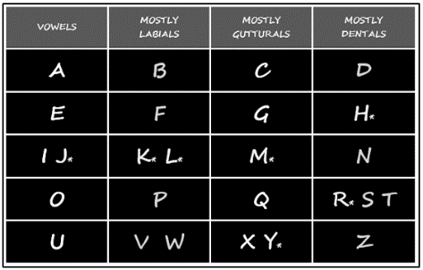

Figure 16

Step 3 The Western Alphabet Grid

Note the differing order of the phoneme classes.

These tables show various steps backwards in time in my attempt to retro-iterate the past.

If done right, a simple table should be the result which at some point in time could have served as a model for the first western tabular alphabet.

As we will see later, it would be the Step 3 table.

There is some variety in the representations of the current Devanāgarī abugida.

I spent much time finding a collection of letters (aksharas)[14] that was common to most variations. After an initial simplification, the Step 5 table of Figure 15 was the result.

The tabular format and the shades of grey of the columns (originally in colour) make it easier to show the retro-constructing iterations.

I have not attempted to establish any dates of when these proposed transitions may have taken place, **but it may well be possible (troops of Julius Caesar accidentally burned the Alexandrian library down during or after the Siege of Alexandria in 48 BC) that ancient records may have shown evidence of such transitions [19, 20] - which possible evidence is now lost.**

In addition, there were three more occasions that the Alexandrian Library was partially or completely destroyed: the attack of Aurelian 270 - 275 CE, the decree of Coptic Pope Theophilus of Alexandria in 391CE, and the Muslim conquest of Egypt in (or after) 642 CE.

## Stage 3e - Step-by-Step Retro-iterating

I am purposely showing the following numbered list in ascending *and* descending order: e.g. number 5 (standing for the fifth retro-iteration) produced Step 1 - one of the earliest proposed abugidas, which represents only nine phonemes/graphemes.

I propose, that it was at the time of Step One (many thousands of years ago), that symbols were scratched (*graphemes*) into hardened soil in a tic-tac-toe formation, graphemes that initially mimicked graphically the sounds (*phonemes*) according to the shape of the mouth or position of the tongue (C. Bhide, 2015[15]). I suggest that this was done to teach children to speak properly and to acquire the first step to writing - engraving actually - hence the word *grapheme*.

1. Step 5

This table is a hypothetical approximation of what scribes preceding Pāṇini, may have worked with. Note that the columns are labelled: “1a, 1b, 2a, 2b, 3”.

1. Step 4

This table is a representation of a transition stage when gutturals & palatals (labelled “1ab”) as well as cerebrals & dentals (labelled “2ab”) were being distinguished by even earlier scribes.

1. Step 3

This study proposes that an ancient grid much like the Step 3 table, stood model for the western alphabet table (Figure 16). As noted before, the columns of Figure 16’s tables have a different order. This is why I propose that at some point in ancient times an accidental “column swap” must have occurred, while subsequently also insertions were made and more positioning errors crept in. (See upcoming **Stage 4 - Swap and Shift** which also features the narration about an ancient Near Eastern Scholar visiting India.)XX

Figure 16 Step 3 above, shows a twenty-field grid in which the number of characters increased from 19 to 20 when the ओ (O) became included. (Figure 17 does not feature the ओ.)

For the western alphabet, we arrive at the same number: 20 - not 26 - when we consider in the following points that 6 characters were only inserted *after* 700 BCE (See Footnote 20):

* + 1. The V and W were originally just the V[16] (often written or chiseled as a U).
    2. The X, Y and Q were Latin and Greek letters,
    3. In some languages, G and H are phonetically the same.
    4. In ancient Latin, I and J were interchangeable.

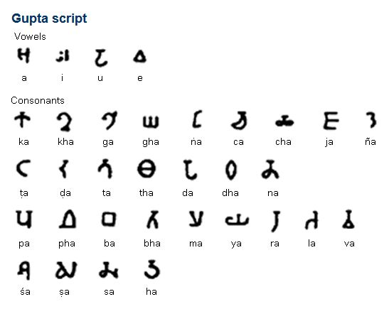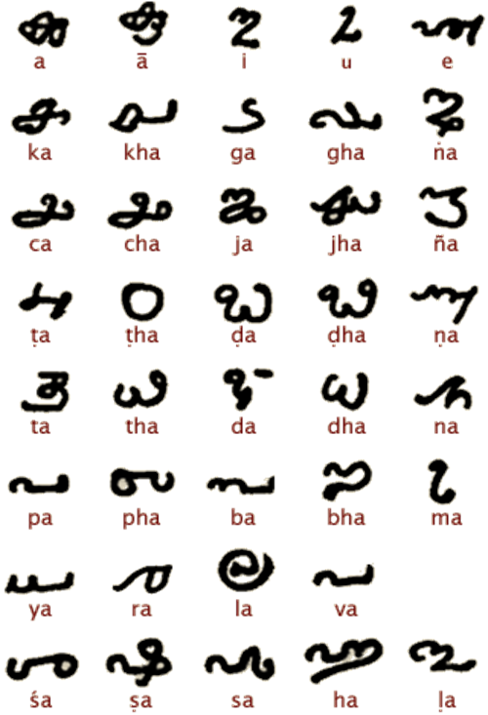

Figure 17

Top: Gupta Vowels

Bottom: Granthi Vowels

1. Step 2

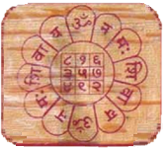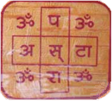

Centre Square

9 Field Number Yantra

Figure 8

Grid

9 Field Letter Yantra

This is an intermediate retro-iteration to Step 1. Step 2 must have taken place when vowel sounds came to be considered more than just short vocal outbursts of wonder, fear, surprise and exclamations of pain or pleasure, etc.

I am not showing the O sound in all of the steps, as, when I studied very early versions of Brāhmī, Gupta and Granthi abugidas, the O was missing in several cases (Figure 17).

Phonetically the O, U and V are very close. I have not been able to pinpoint though, even if vaguely, when the O phoneme became part of the abugida.

It is important to consider that the use of vowel phonemes must have preceded the use of consonants by perhaps thousands of years as Primates, Neanderthals, Cro-Magnon and early Homo Habilis and Sapiens were already making use of them “hooting and hollering”.

1. Step 1

This 9-field table features no vowels at all. Incidentally, in Hindu tradition, a “tic-tac-toe” like structure (Figure 18) may have stood model for character and numerical yantras. It is interesting that the numbers 1 to 9 are used in these types of yantras. Whichever ancient person had set-up the 9-field phoneme-grapheme grid as in Step 1, he had not written his symbols on bark, parchment or paper but scratched them with a stick into hardened soil.

Whatever shapes were scratched though, they were not lettering yet, they were figurative scratches - *graphemes*, that represented voiced human sounds - *phonemes*.

It must have been more that 4000 years ago in India, that the earliest pre-Pāṇini linguists already had discovered that the sounds we make to vocally and verbally communicate:

* + 1. consonants
    2. vowels

can be categorized according to where in the mouth they are articulated: from the throat (larynx) to the front of the mouth (lips) and places in between (Figures 19, 20, 21).

Figure 19 - Right

Vowels

Figure 20 - Left Consonants

Articulation Positions

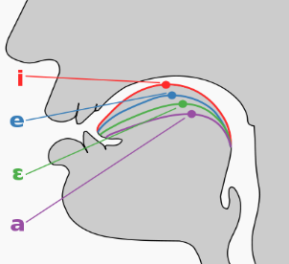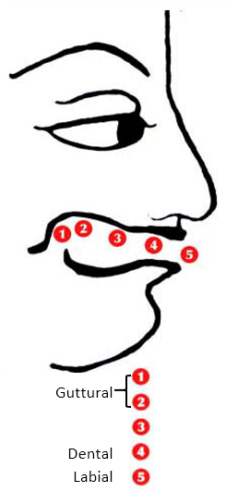

Figure 21

Possibly the first consonants recognized.

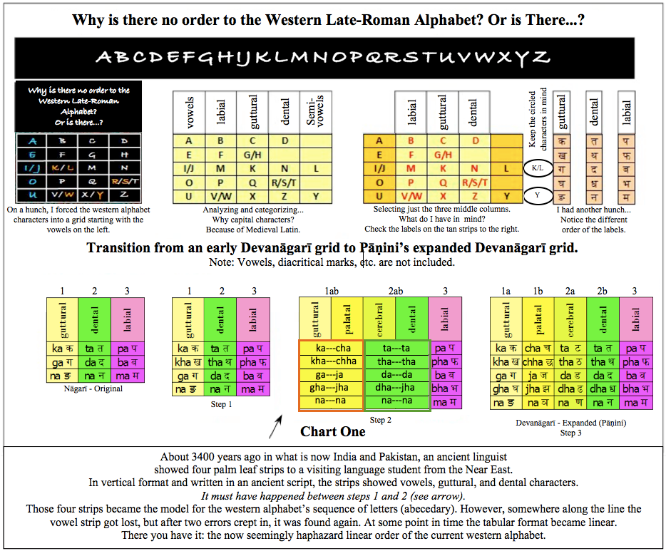

**ka**

**ta**

**pa**

When, over time, voiced communication became more nuanced, additional nuanced sounds were recognized:



Figure 22

Compare this table with Figure 23,

Notice the sequence of the phoneme columns:

1 vowels, 2 labials, 3 gutturals, 4 dentals.



Figure 23

In this reverse retro-engineered table, notice how the phoneme column sequence differs from Figure 22:

1 vowels, 2 gutturals, 3 dentals 4 labials.

* + 1. three nuances of the guttural[17] k phoneme:   
       ka ga nga,
    2. three nuances of the dental t phoneme:  
       ta da na,
    3. three nuances of the labial p phoneme:   
       pa ba ma.

When one puts those phonemes in a tic-tac-toe like grid it looks like:

* + 1. ka ta pa,
    2. ga da ba,
    3. nga na ma.

I propose that in all likelihood, this 9 field “ka ta pa” grid was one of the earliest, if not the earliest alpha-syllabic abugida.

When one adds 5 (or 4) vowels to 9 consonants, one gets 14[18] (or 13) phonemes.

When an ancient person discovered that graphemes could represent sounds (instead, of as happened later, writing them on bark or palm leaves) he scratched them with a stick into hardened soil. Whatever shapes he scratched though, they were not letters yet, they were figurative scratches - graphemes - that represented voiced human sounds - phonemes.

*This was the beginning of the use of*

*graphemes / script symbols / characters*

*to eventually form written words.*

1. Step 0

Figure 24

From left to right:

A. Original order.

B. The vowel “strip” got mislaid and the labial “strip” was moved from the third position to first.

C. The vowel “strip” was found again and was put to the left of the labial column.

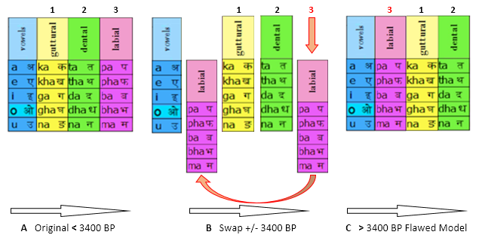

In this step I probably went too far retro-engineering, risking plausibility. But in those pre-historic days, when voiced communication was beginning to be more nuanced, in addition to phonetic exclamations (the vowel phonemes A, E, I, (O), U formed by air passing from the larynx over the tongue), three consonant phonemes were recognized:

* + 1. the guttural k sound,
    2. the dental t sound,
    3. the labial p sound.

## Stage 4 - Swap and Shift

As has be seen in the **Discussion** section,   
*“***Stages 1 and 2 - Inklings & Serendipity and Finding Patterns***”,* the methods and processes that were applied, resulted in *two suitable tabular grids* that we are now ready to compare:

1. Figure 22 - The “Western” four by five columns-and-rows table constructed from the western abecedary’s alphabet sequence of letters, as copied from the “Napkin” grid.
2. Figure 23 - The 4 x 5 column and row table that was reverse retro-engineered in Step 3 from the Devanāgarī abugida. I added the O, as at the time of copying from the table of Figure 22, the O was already in use.

## Stage 5 - Mix and Match

If indeed the western alphabet grid was modelled after an earlier South Asian abugida, we must find out how that took place. As well, must find out, ***if*** *there are differences*, how those differences came about.

Looking superficially at the phonetic classes in Figures 22 and 23, they appear similar, but, as pointed out before, on closer inspection of the order of the various consonant phoneme groups, it appears that a column **swap** has occurred.

Figure 24 is an attempt to graphically recreate that event. Its three steps demonstrate that sequence (notice the large arrows A, B, C and the dating). How it possibly took place in *‘reality’*, will be told later in the form of a narration.

It resulted in **Arrow C > 3400 BP Flawed Model**… but why flawed…? (Figure 24).

Looking at the **Arrow B** set of columns, it demonstrates how, by moving *labial column 3* to a position between the *vowel column* and the *guttural column 1*, that the order turns out to be the same as the later western reconstructed tabular alphabet order of phoneme classes (Figure 22).

This means that during the copying and modelling process, a mishap must have occurred - actually, as we will see later, two mishaps (and even a few more later).

The caption of Figure 24 provides more detail.

In my book “Alphabet or Abracadabra? - Reverse Engineering the Western Alphabet” [4] I sketch a scenario about how that swapping might have occurred. In the following narration I am retelling that story in a different and more extended fashion: a hypothetic story, meant to paint a picture of ancient times:

*“In a scene that may have taken place a very long time ago - much more than 4000 years - an ancient South Asian grammarian / teacher was scratching symbols in the hardened soil in front of him, for a number of young attentive students. He was helping them to pronounce the sounds that the symbols stood for, urging them also to remember the shapes of those scratched marks.*

*The grid that he drew the symbols in, consisted of (you guessed it) twenty squares, a columns and rows table of four by five fields.*

*Then a visiting scholar, probably from the Near-East, happened to come by. He had heard about this Indian master who had come up with a new science:*

*The science of sounds and symbols:  
phonemes and graphemes  
“grammar”[19].*

*He was very keen to have a copy of wat was scratched in the sand, and he asked the learned teacher if he could make him a copy of that grid in the sand. The teacher proceeded to get four dried palm leaves, and on them he inked in the symbols: The first palm leaf he inscribed vertically with the sounds A E I O U, while he explained that those sounds were formed by passing air from the throat over the tongue while shaping the mouth.*

Figure 25

Left

What the visiting linguist saw.

Four strips of palm leaves in their original order.

Vowels: ka - ta – pa

Right

What he mistakenly reconstructed.

Four strips of palm leaves in the wrong order.

Vowels: pa – ka - ta

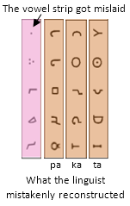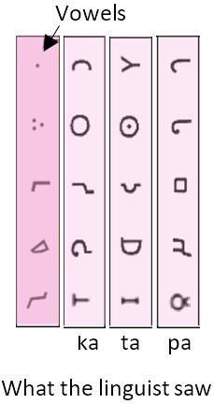

ka ta ***pa*** ***pa*** ka ta

vowels

vowels

*On the second leaf he drew symbols that represented sounds that also came from the back of the mouth and sounded like Ka Kha Ga Gha nGa.*

*On the third leaf he inked the sounds that come from the front, using the teeth, they sounded like Ta Tha Da Dha nDa.*

*The fourth leaf became inscribed with symbols for the sounds made by the lips, they sounded like Pa Pha Ba Bha Ma.*

*Notice: from the back of the mouth to the front.*

*If it would have been Brāhmī, the four strips would have looked like Figure 25 left.*

Figure 26

The asterisked letters K, L, M, and H ended up in the wrong columns.

The asterisked J, Y, and R found their place for different reasons.



*After he had learned enough, the visiting scholar returned home (probably in the Near-East), but somewhere along the way he mislaid the vowel strip. When he attempted to arrange the remaining three strips, he had forgotten their original “ka ta pa” order, and while muttering, “Which palm leaf strip came first?” he made his best guess…*

*Unfortunately, he had it wrong (Figure 25, strips on the right side).*

Some time later - luckily - he or someone else found the vowel strip again and put it to the left of the “pa ka ta” strips.

We cannot know if it was the visiting Near- Eastern linguist who converted the script he copied, to later script styles. In any case, he did not use Roman script characters nor Greek or Semitic or Aramaic ones… he was from a time much before those scripts developed.”

## Stage 6 - Insert and Delete

Upon much closer inspection, we find that a number of characters in the western alphabet table (Figure 26) are not in the same locations as in its flawed abugida model (Figure 24 C).

As well, extra characters had been inserted.

R. G. Lehmann [21] claimed in 2012 that changes in content and order of the Latin alphabet came from a Western Semitic *Abgad.* I claim instead that they came from a Near-Eastern one.

Initially it was not clear how the characters could get so mixed up, compared to what was used as a model at its ancient South Asian beginnings. But when the *row* format is focused on, it does not take long to see a pattern. The reverse, retro-engineering method was again useful to create a sequence of changes that might have taken place, changes that gave rise to the final tabulation of the western alphabet. When this might have taken place, is hard to pinpoint as no direct evidence is available, but it is useful to keep the current consensus view in mind, even if it is not according to my view.

*“The script was spread by the Phoenicians across the Mediterranean. In Greece, the script was modified to add the vowels, giving rise to the ancestor of all alphabets in the West. The vowels have independent letter forms separate from the consonants, therefore it was the first true alphabet. The Greeks chose letters representing sounds that did not exist in Greek to represent the vowels. The vowels are significant in the Greek language.”  
~ Bright and Daniels 1996 [22]*

When the bottom row of Table A in Figure 27 (here separated) gets moved up and shifted over: *moved two rows up and shifted one cell to the right (Table B)*, it opens up the spot where the K and L were inserted, while also (after another small shift in position) the nasal ङ (ṅa) was dropped.small shift in position) the nasal ङ (ṅa) was dropped. (This phoneme was not used at the time of construction of the Old Latin Alphabet ca 700 BCE) [20].

The vowel columns in tables A and C come into play when the percentage match between the reverse retro-engineered tables B and western alphabet table C is calculated. When comparing Table C’s *circled consonants* with table B’s reverse retro-engineered reconstruction, 13 out of 15 characters match. These characters have a similar pronunciation as their Devanāgarī counterparts.

*If* ***only*** *the table in Figure 15 Step 3 would have been constructed, the match between Step 3 and table C would have been 25 % (5 out of 20).*

**While accounting for the cell displacements and including the vowels, but excluding insertions made in the Old Latin Alphabet at around 700 BCE, a character match between tables B and C of 18/20 or 90 % is obtained.**

## Stage 7 - Aftermath and Dating

The Ugarit cuneiform abecedary clay tablet (Figure 28a) from Syria (ca 1400 BCE) provides evidence that a “West-of-India” style alphabetic *sequence* was already in use prior to 3400 years ago. It was an abecedary modeled after a vowel-less western version of a tabular alphabet, **but****only after that tabular form had undergone changes and had also shown up in linear form**.

Dating the linearization has not been possible. If there ever were records of such changes, they may have been destroyed by the fire of the Alexandrian Library. (See Footnote 7)

*“The traditional order of the signs had been fixed no later than the fourteenth century B. C.* *The fact that both archaic (non-Ugaritic) elements and local adaptations are recognizable in the order suggest that the ordering is considerably older, and was well established by that time.”*

*~ Frank Moore Cross Jr, Thomas O Lambdin (1960) (See Footnote 7)*

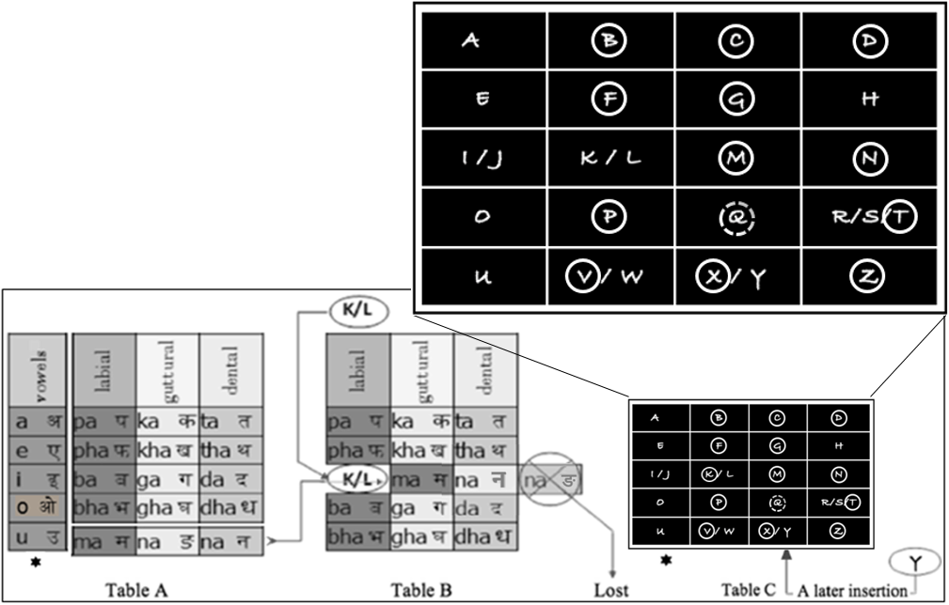

Figure 27

The five vowel positions (asterisks) of tables A and C match - I and J are interchangeable.

The ओ (O) was part of the abugida by this time (see Figure 13 Step 3).

When the bottom row of table A (here separated) gets moved up and shifted over

two rows up and one shift to the right (as shown in table B), it opens up the spot where the K and L were inserted, while also the nasal ङ (ṅa) which was not used at the time of construction of the Old Latin Alphabet (7th century BC) was dropped. See Footnote 20 for a link to the history of adaptation and arrangement of letters in the beginning of the current era.

*The vowel columns in tables A and C come into play when the percentage match between the reverse retro-engineered tables B and western alphabet table C is calculated.

When comparing table C’s circled consonants with table B’s reverse retro-engineered reconstruction, 13 out of 15 characters match. These characters have a close or similar pronunciation as their Devanāgarī counterparts.

While accounting for cell displacements, and including the vowels. but excluding insertions made at around 700 BCE, the character match between tables B and C is 18/20 or 90 % (18 out of 20).

If only the table in Figure 13 Step 3 would have been constructed,

the match would have been 25 % (5 out of 20).

* As the vowel column was re-added after the column swapping, this column is shown separately, in table A.

We can conclude from that, that the ‘errors and omissions’ must have taken place quite some time before 1400 BCE, as the Ugarit cuneiform script appears to be well established. Hence it can be estimated that the time it took for its evolution, must have been over a number of generations.

Figure 28b

Decipherment

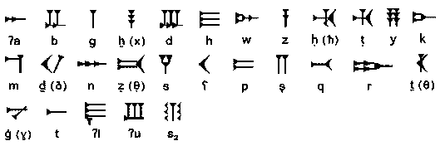

Figure 28a

Earliest cuneiform alphabet abecedary found

To be read from left to right.

Ugarit, Syria, ca 1400 BCE

Clay tablet, 20 by 5.6 cm

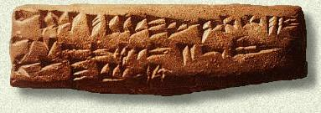

It can thus be concluded that well before 3400 BP, the current western “Late-Roman Alphabet” character sequence[21] (the linear ABC or abecedary) was modeled after a pre-Sanskrit Devanāgarī-like character grid (abugida or alphasyllabary).

Because of the difference between linear and grid (tabular) formats, that modeling can of course only become evident, when enough of a similarity is observed between the linear abecedary characters and the tabular sequence of letters in a *Pre-Ashokan* Brāhmī or Pre-Sanskrit abugida - **which has been demonstrated**.

More than 3400 years ago, a number of vowels (like those of the Ugarit clay tablet) were added to a table with Near-Eastern, pre-Ugarit consonants, but only after the columns and rows in that Near-Eastern table had already - mistakenly - acquired their wrong order and received extra consonants. This eventually resulted in the Ugarit abecedary (Figures 28a, b).

Figure 29

Ivory writing tray

Greek / Etruscan

Marsiliana d’Albegna Etruria

700 BCE

20 by 11 cm

This artefact combined the Etruscan and Greek abecedaries.

It is the oldest of its kind found.

The tray contained solid wax and was used to practice writing on by scratching its wax surface with a stylus.

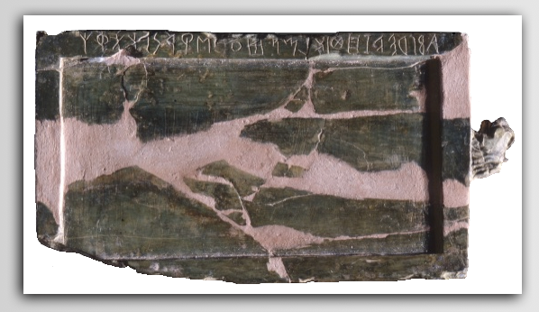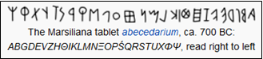

At some point (when exactly is hard to establish) that final Near-Eastern Ugarit table **or** **a similar non-Ugarit model** - after it was completed with 5 vowels - lost its tabular format in stages This eventually resulted in the single, non-logical sequence of characters of the Western alphabet (abecedary), while it along the way also inherited various characteristics from preceding Phoenician, Aramaic, Hebrew, Greek and Roman versions.

Compared to the cuneiform Syrian Ugarit abecedary, the Marsiliana d’Albegna (Figure 29) abecedary from ca 700 BCE, contains more vowels… **and** the same errors that the ancient language student and his successors had made… **but** in a linear sequence.

## CONCLUSION

In spite of it looking quite disorderly, the western “Late-Roman Alphabet” linear letter sequence (abecedary) has been found to be modelled after an ancient Pre-Sanskrit orderly pattern - an alpha-syllabic abugida - a tabular pattern that categorizes sounds by how and where they are articulated in the mouth.

This modelling must have taken place between 3400 and ca 4000 years ago.

This study retraced how *steps-wise and over time*, the western linear alphabet had changed from this earlier tabular alphabet format which *closely resembled* the tabular model of a reverse retro-engineered early South Asian 'abugida' or 'alpha-syllabary'.

This change process included a number of 'swaps’, ‘errors and omissions’ as well as later intended insertions and additions:

* + 1. The inadvertent swapping by a Near-Eastern scribe of strips of media - most likely palm leaves - on which the *vargas* (phoneme groupings) were recorded in a vertical manner,
    2. An inadvertent shift upwards and sideways of a small set of graphemes/phonemes,
    3. Purposely made changes, deletions and insertions.

***All this resulted in the apparent disorder of the current western 'ABC'.***

In this study these errors were tracked across a number of ancient alphabets. Not only was the copying process reconstructed using the reverse retro-engineering method, but an approximation of a *terminus ante quo* (prior to 1400 BCE) for the copying and modelling by the Near Eastern Linguist was also established based on a ca 3400-year-old Ugarit cuneiform clay tablet.

When the western alphabet *in tabular* form is superficially compared with an earlier and simple “reverse retro-engineered” Sanskrit abugida a percentage of similarity of only 25 % (5 out of 20) is calculated. However, after the error identification, and while considering the varying but close pronunciations of several comparable characters in side-by-side alphabet and abugida grids, and while focusing on the placement of several *Late*-Roman Alphabet characters in their appropriate vowel, labial, guttural and dental columns *but* excluding insertions made in the *Old Latin Alphabet* at around 700 BCE an 18/20 or 90 % is obtained.

# BIBLIOGRAPHY

1. Steve T. Bett. 1996. *The Origin of the Alphabet*.
2. Wim J. Borsboom.2015. *Alphabet or Abracadabra? - Reverse Engineering the Western Alphabet.* Friesen Press ISBN 978-1-4602-6230-6*.*
3. George Cardona. 1997. *Pāṇini: A Survey of Research.* Motilal Banarsidass Publ ISBN 81-208-1494-0.
4. Frank Moore Cross Jr, Thomas O. Lambdin. 1960. *A Ugaritic Abecedary and the Origins of the Proto-Canaanite Alphabet*. In Bulletin of the American Schools of Oriental Research Nr. 160.
5. Peter T. Daniels, William Bright (editors). 1996. *The world's writing systems.* New York. Oxford University Press.
6. Orly [Goldwasser.](http://en.wikipedia.org/wiki/Orly_Goldwasser)  2010. [*How the Alphabet Was Born from Hieroglyphs*](http://www.bib-arch.org/bar/article.asp?PubID=BSBA&Volume=36&Issue=02&ArticleID=06)*.* Biblical Archaeology Review (Washington, DC. Biblical Archaeology Society) 36 (1). [ISSN](http://en.wikipedia.org/wiki/International_Standard_Serial_Number) [0098-9444](http://www.worldcat.org/issn/0098-9444).
7. Salomon Richard. 1995. *On the Origin of the Early Indian Scripts, A Review Article.* Journal of the American Oriental Society 115.2 (1995). Pages 271-279.
8. Richard Salomon. 1996. *Brāhmī and Kharoshthi in The World’s Writing Systems.*
9. William Schniedewind, Joel Hunt. 2007. *A primer on Ugaritic.*
10. Isaac Taylor. 2003. [*History of the Alphabet: Aryan Alphabets.* Part 2](http://books.google.com/books?id=kLlBuOybNMQC). Kessinger Publishing. [ISBN](http://en.wikipedia.org/wiki/International_Standard_Book_Number) [9780766158474](http://en.wikipedia.org/wiki/Special:BookSources/9780766158474).  
    *“[...] In the Kutila this develops into a short horizontal bar, which, in the Devanagari, becomes a continuous horizontal line [...] three cardinal inscriptions of this epoch, namely, the Kutila or Bareli inscription of 992, the Chalukya or Kistna inscription of 945, and a Kawi inscription of 919 [...] the Kutila inscription is of great importance in Indian epigraphy, not only from its precise date, but from its offering a definite early form of the standard Indian alphabet, the Devanagari [...]”*
11. L. A. Wadell. 1927. *The Aryan Origin of the Alphabet.* Luzac & Co, London.
12. L. S. Wakankar. 1968. Ganesh Vidya, The traditional Indian approach to Phonetic Writing.

# REFERENCES

1. https://www.slideshare.net/EnricJardi/cnon-tipogrfic-1-presentation (Retrieved January 2019)
2. Roy Norman Kenneth*.* 2005. *Buddhist Forum Volume V: Philological Approach to Buddhism*. Routledge. pp. 67, 56–57, 65–73. ISBN 978-1-135-75154-8.
3. Frank Moore Cross Jr, Thomas O. Lambdin. 1960. *A Ugaritic Abecedary and the Origins of the Proto-Canaanite Alphabet.* Bulletin of the American Schools of Oriental Research Issue 160.
4. Wim J. Borsboom.2015. *Alphabet or Abracadabra? - Reverse Engineering the Western Alphabet.* Triple Gem Press ISBN 978-0-9780813-3-1.
5. Wim J. Borsboom.2015. *Alphabet or Abracadabra? - Reverse Engineering the Western Alphabet.* Friesen Press ISBN 978-1-4602-6230-6.
6. https://www.myind.net/Home/viewArticle/alphabet-or-abracadabra (Retrieved January 2019)
7. Harald Haarmann. 2004. *Geschichte der Schrift [History of Writing]* (German) (2nd ed.). München: C. H. Beck. ISBN 3-406-47998-7.
8. David Sacks. 2003. *Language Visible: Unraveling the Mystery of the Alphabet from A to Z.*
9. Peter T. Daniels, William Bright. 1996. *The World's Writing Systems*. Oxford University Press.
10. J. T. Hooker et al. 1990. *Reading the Past: Ancient Writing from Cuneiform to the Alphabet*. Berkeley University of California Press.
11. Andrew Robinson. 1995. *The Story of Writing: Alphabets, Hieroglyphs & Pictograms.* New York, Thames & Hudson Ltd.
12. https://www.slideshare.net/EnricJardi/cnon-tipogrfic-1-presentation (Retrieved January 2019)
13. https://www.myind.net/Home/viewArticle/alphabet-or-abracadabra (Retrieved January 2019)
14. L. S Wakankar. 1968*. Ganesh Vidya - The traditional Indian approach to Phonetic Writing*
15. http://dnaofwords.blogspot.ca/2012/01/normal-0-false-false-false-en-in-x-none.html (Retrieved January 2019)
16. L. A. Wadell. 1927. *The Aryan Origin of the Alphabet* Luzac & Co, London.
17. Jainism. source: indoeurohome.com (Retrieved January 2019)
18. Maurice Winternitz. 1985.
19. Justin Pollard, Howard Reid. 2006. *The Rise and Fall of Alexandria, Birthplace of the Modern World.*
20. MacLeod Roy: 2004, The Library of Alexandria: Centre of Learning in the Ancient World. I. B. Tauris. p. 70-74. ISBN 978-1850435945.
21. Reinhard G. Lehmann. 2012. *27-30-22-26, How Many Letters Needs an Alphabet? The Case of Semitic*. Quoted in Alex de Voogt, Joachim Quack. 2012.*Writing across borders*” edited by Friedrich, Leiden, Brill 2012, (p. 11-52).
22. Peter T. Daniels, William Bright (editors). 1996. *The world's writing systems.* New York: Oxford University Press. Pgs. 92 to 96.
23. https://en.wikipedia.org/wiki/Old_Italic_script

1. An abugida is a series of writing characters (aksharas) in which each complex non-vowel character (e.g. the Sanskrit फ pha) represents the sound of a complex consonant-vowel combination. It is not a complete syllable though. When an abugida character (an alpha-syllable) is pronounced by itself, it ends with a short ‘a’, however, that short ‘a’ is not all the time pronounced when that character’s sound is part of a word. For example, देवनागरी is pronounced devnāgrī [[d̪eːʋˈnaːɡri]](https://en.wikipedia.org/wiki/Help:IPA_for_Hindi_and_Urdu) - not devanāgarī.

   All early and current Indian abugidas (Brāhmī, Nāgarī, Devanāgarī) are in a tabular format.
2. Several changes in contents and order of the Latin alphabet were derived from either a Phoenician or a Northwest Semitic *Abgad* (Reinhard G Lehmann, 2012). Whether and how this *abgad* was derived from a much earlier South Asian abugida, is the subject of this study.

   As no direct data of such derivation is available (possibly due to various destructions of the ancient Alexandrian library), this study applies a - for this field of research - novel method of reconstructing what could have taking place: “Reverse Engineering”.
3. Not to be confused with the origin of the graphic design of western alphabet letters. This analysis was never intended to trace the formation or shape of individual script characters or any formative link between various scripts.
4. I have added the prefix “retro”, to indicate that the reverse engineering method - as applied in this study - aims to find and recreate older or more original models, rather than reverse engineering a copy of a current model.
5. While accounting for the cell displacements and including the vowels, *but* excluding insertions made in the *Old* Latin Alphabet at around 700 BCE.
6. The topic of this paper was first conceived by the author in 1975. It was informally presented at the International Conference on Ancient Indian Civilization, Los Angeles 2009. In 2012 this informal presentation was expanded into booklet and format and published in Canada [4] under the title *“Alphabet or Abracadabra? - Reverse Engineering the Western Alphabet”.* In 2015 it was published in book format [5]. Also in 2015, a special low-cost print release was privately distributed in India*.*

   An interview with the author by Mr. Nilesh Oak on this topic was published online [6].
7. "A.E.I.O.U." was a symbolic device personally used by the Habsburg emperor Frederick III (1415–93), who had a fondness for mythical formulae. (Brewer, E. Cobham 1978)
8. In this study, I am proposing, that in the early beginnings of alphabetic phonetic writing, there existed a simple rudimentary classifica­tion of phonemes based on where in the mouth basic sounds were articulated (Figure 18). I found that in addition to the vowel classification, the use of the below listed consonant groups: groups 4 (velars) and 5 (palatovelars) - *in this study they are labeled together as gutturals, and it will be shown why (see Figure 6) -* as well as groups 8 (dentals) and 9 (labials), was sufficient to back up that claim. Guided by that simple classification and for the specific purpose of this study, I therefore concentrated on just the vowel, guttural, dental and labial phonemic categories.

   Comprehensive List of Consonants:

   1 Laryngeals, 2 Pharyngeals, 3 Uvulars, 4 Velars, 5 Palatovelars, 6 Sibilants, 7 Interdentals, 8 Dentals, 9 Labials, 10 Liquids, 11 Nasals.
9. According to the *Centum Satem* isogloss, the grapheme C can be pronounced as the phonemes C or K.
10. L. S. Wakankar mentions in his “Ganesh Vidya” [14] how Ganesh is taking dictations from Vyasa (3000 BCE), the author as well as the protagonist of the Mahabharata, the Puranas, and the Upanishads. Ganesha is India’s patron of letters and learning. In his booklet, Mr. Wakankar refers to the “Ganapati-Atharva Sheersha”, which describes how “Ganesh Vidya” is about phonology and scriptology. It refers to “drawing of alphabets with paint or varnas” and identifies Ganesha as “the lord of categories - ganas”.
11. All four people used the term “periodic chart or table” referring to Dmitri Mendeleev’s “periodic table of elements”.
12. The c as in **c**oncert. (See Footnote 9)
13. Pāṇini himself mentioned 64 predecessors, 10 of them by name

    Maheswarani Sutrani, *Akṣarasamāmnāya*, (recitation of phonemes).
14. An akshara in Sanskrit grammar is a written character, in Vedanta philosophy means “imperishable”.

    “The akshara or script character is not lost like a spoken sound which, once spoken, is lost to the air that momentarily carried it.

    The akshara being the capture of that sound in a picture is indestructible.” ~ Amit N. Sinha (2012).
15. During a fascinating conversation with Chaitanya Bhide (Mumbai 2015) and a graphical demonstration by him, Mr. Bhide went into much detail about how, “…the shapes of the earliest graphemes must have shown how the tongue and lips are positioned in relation to teeth and palate, and how the breath flowed when each particular sound was produced.” He showed a number of pre-Ashokan Brahmi characters with that characteristic, and demonstrated how several of these rudimentary phonemic graphemes stood model for the earliest ancient script letters.
16. In even earlier stages the O and the V were equivalent
17. Refer to Footnote 8 how in this study the velars and palatovelars were grouped as gutturals.
18. Some scholars suggested that the number 14 here, may well refer to Pāṇini’s Maheswarani Sutrani and the Akṣarasamāmnāya recitation of phonemes, however, after a close look, I did not find enough similarity except for the *principle* of phonetic categorizing.
19. The word “grammar” originally derived from the Greek stem “graphein” - "to draw, write, scrape or scratch" with a stylus on seals or clay tablets, or perhaps with a stick on hardened soil. Its PIE root is *gerbh- "to scratch, carve"
20. For an extensive history of adaptation and arrangement of letters in the beginning of the current era see [23]:

    https://en.wikipedia.org/wiki/Old_Italic_script. - 21 of the 26 archaic Etruscan letters were adopted for Old Latin from the 7th century BC.
21. Not to be confused with the origin of the design of the western alphabet letters. This analysis was never intended to trace the formation or shape of individual script characters or any formative link between various scripts.